Java GUI Application

It is a Students statistical software developed using JFrames and SQLite database. It contains two windows. First window is login window and second window is main window. In the login window if the user provides wrong credentials then error message appears. Login details and student details has been stored in database.

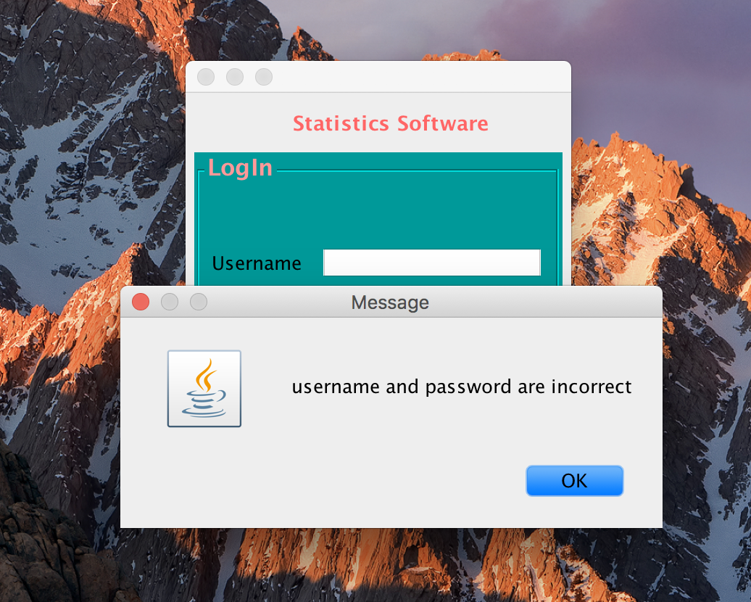

If credentials are correct then main window opens with many panels. In the top panel we can add, edit, delete student information along with photo. It also contains student short information in the table format. Bottom panel contains 5 tabs.

1. First tab is the details tab, which contains full details of the student in top left panel. In the bottom left panel we can generate student report in the pdf format. Finally, the right panel contains indicators for selected student age, weight, height.

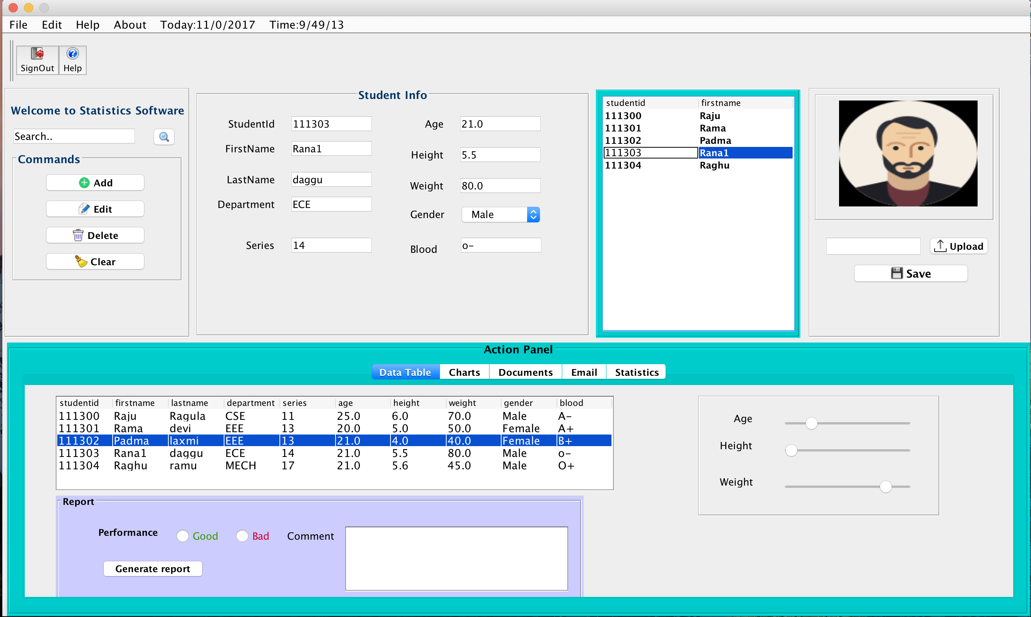

1. Second one is the Charts tab, which shows Pie chart, Bar chart, Line chart for selected student on button click in the left panel. It also shows same type of charts for all students in the right panel.

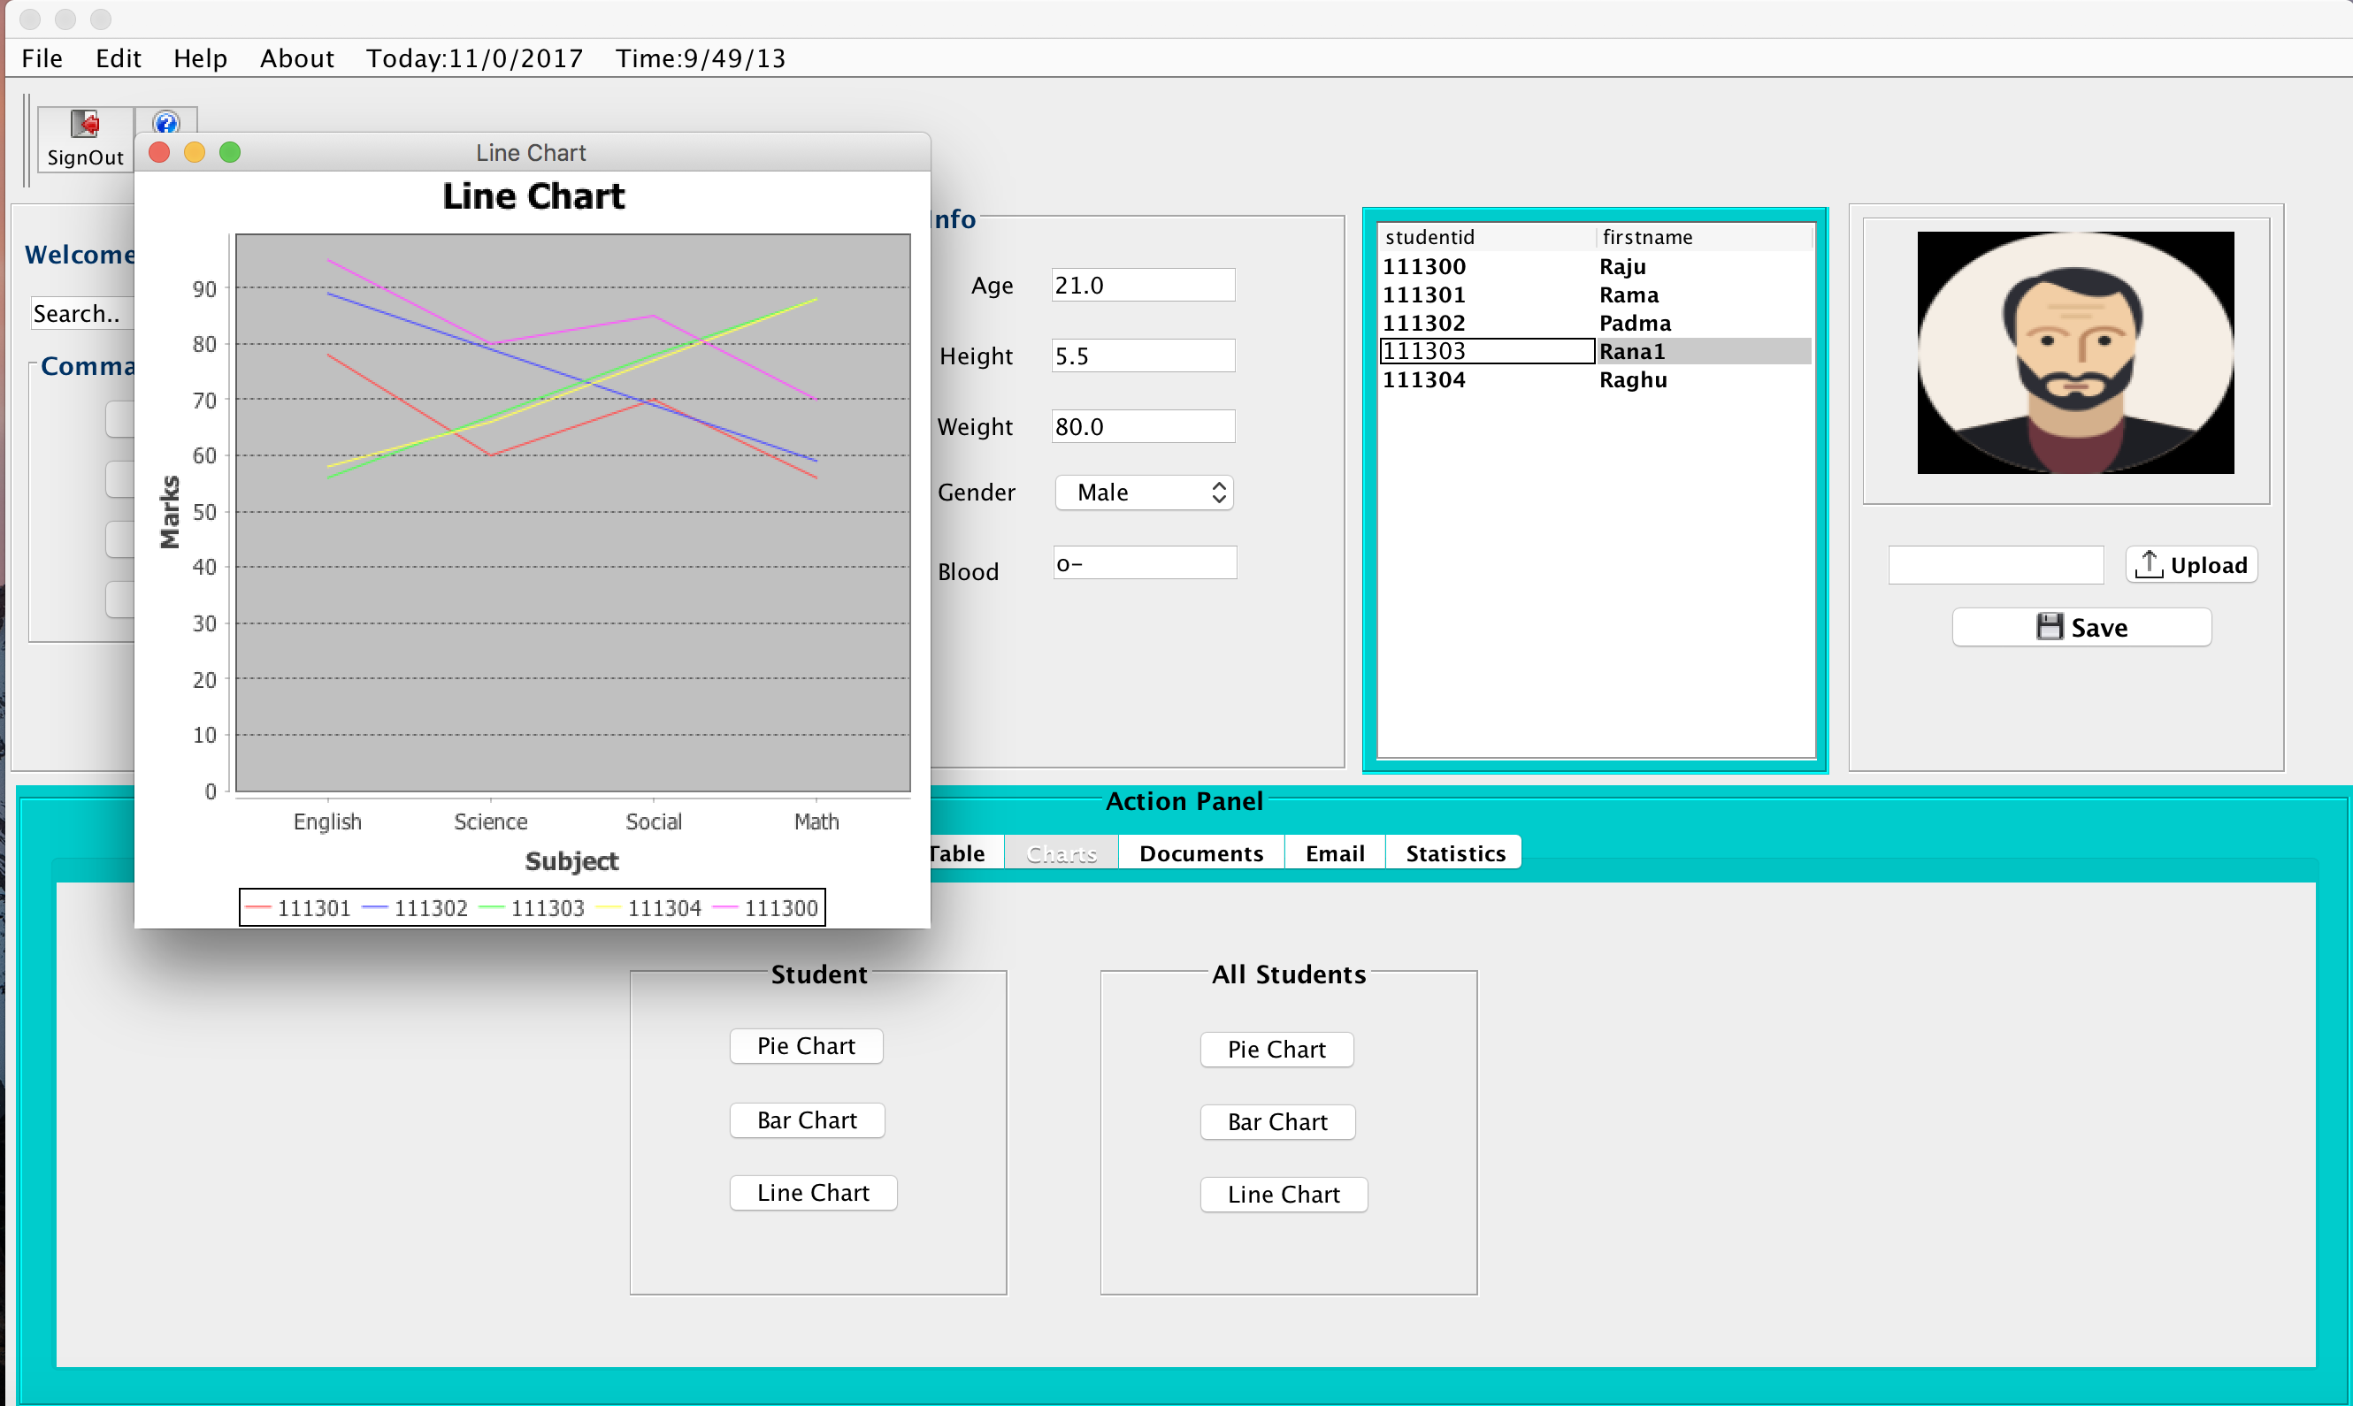

1. Third one is the Documents tab. In this tab we can upload and view the documents for each student.

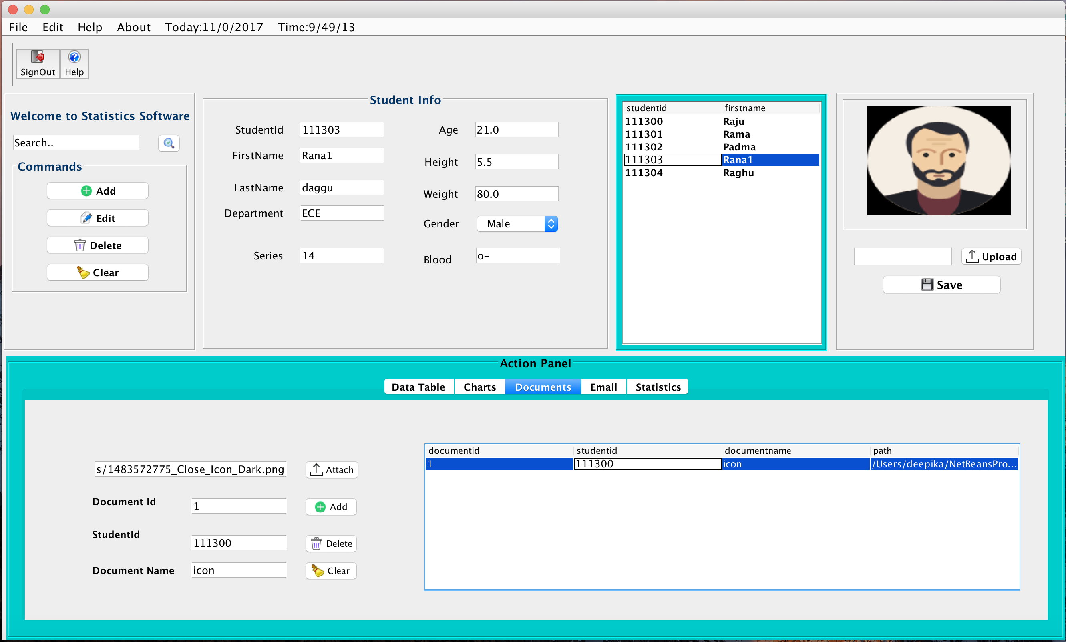

1. Fourth tab is Email, which contains all fields necessary to send email including mail attachment.

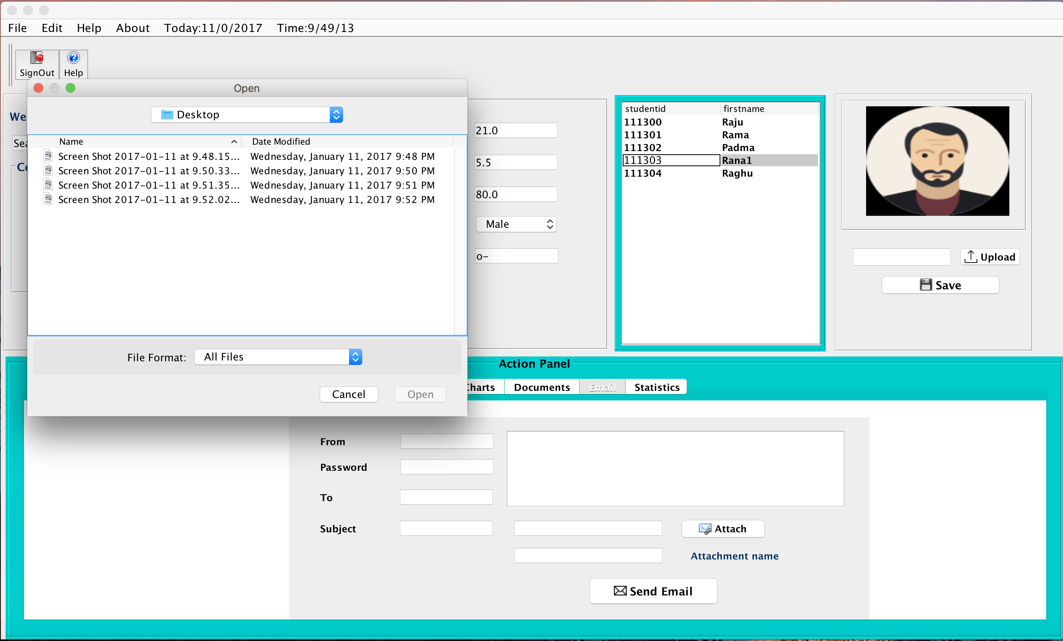

1. Fifth tab is the Statistics tab. It contains 3 sub panels. Left panel shows mean, total, gpa for selected student. Middle panel shows total, grade based on the selected subject from combo box. Finally, right most panel shows number of students, average, lowest marks, highest marks for selected subject and selected exam.

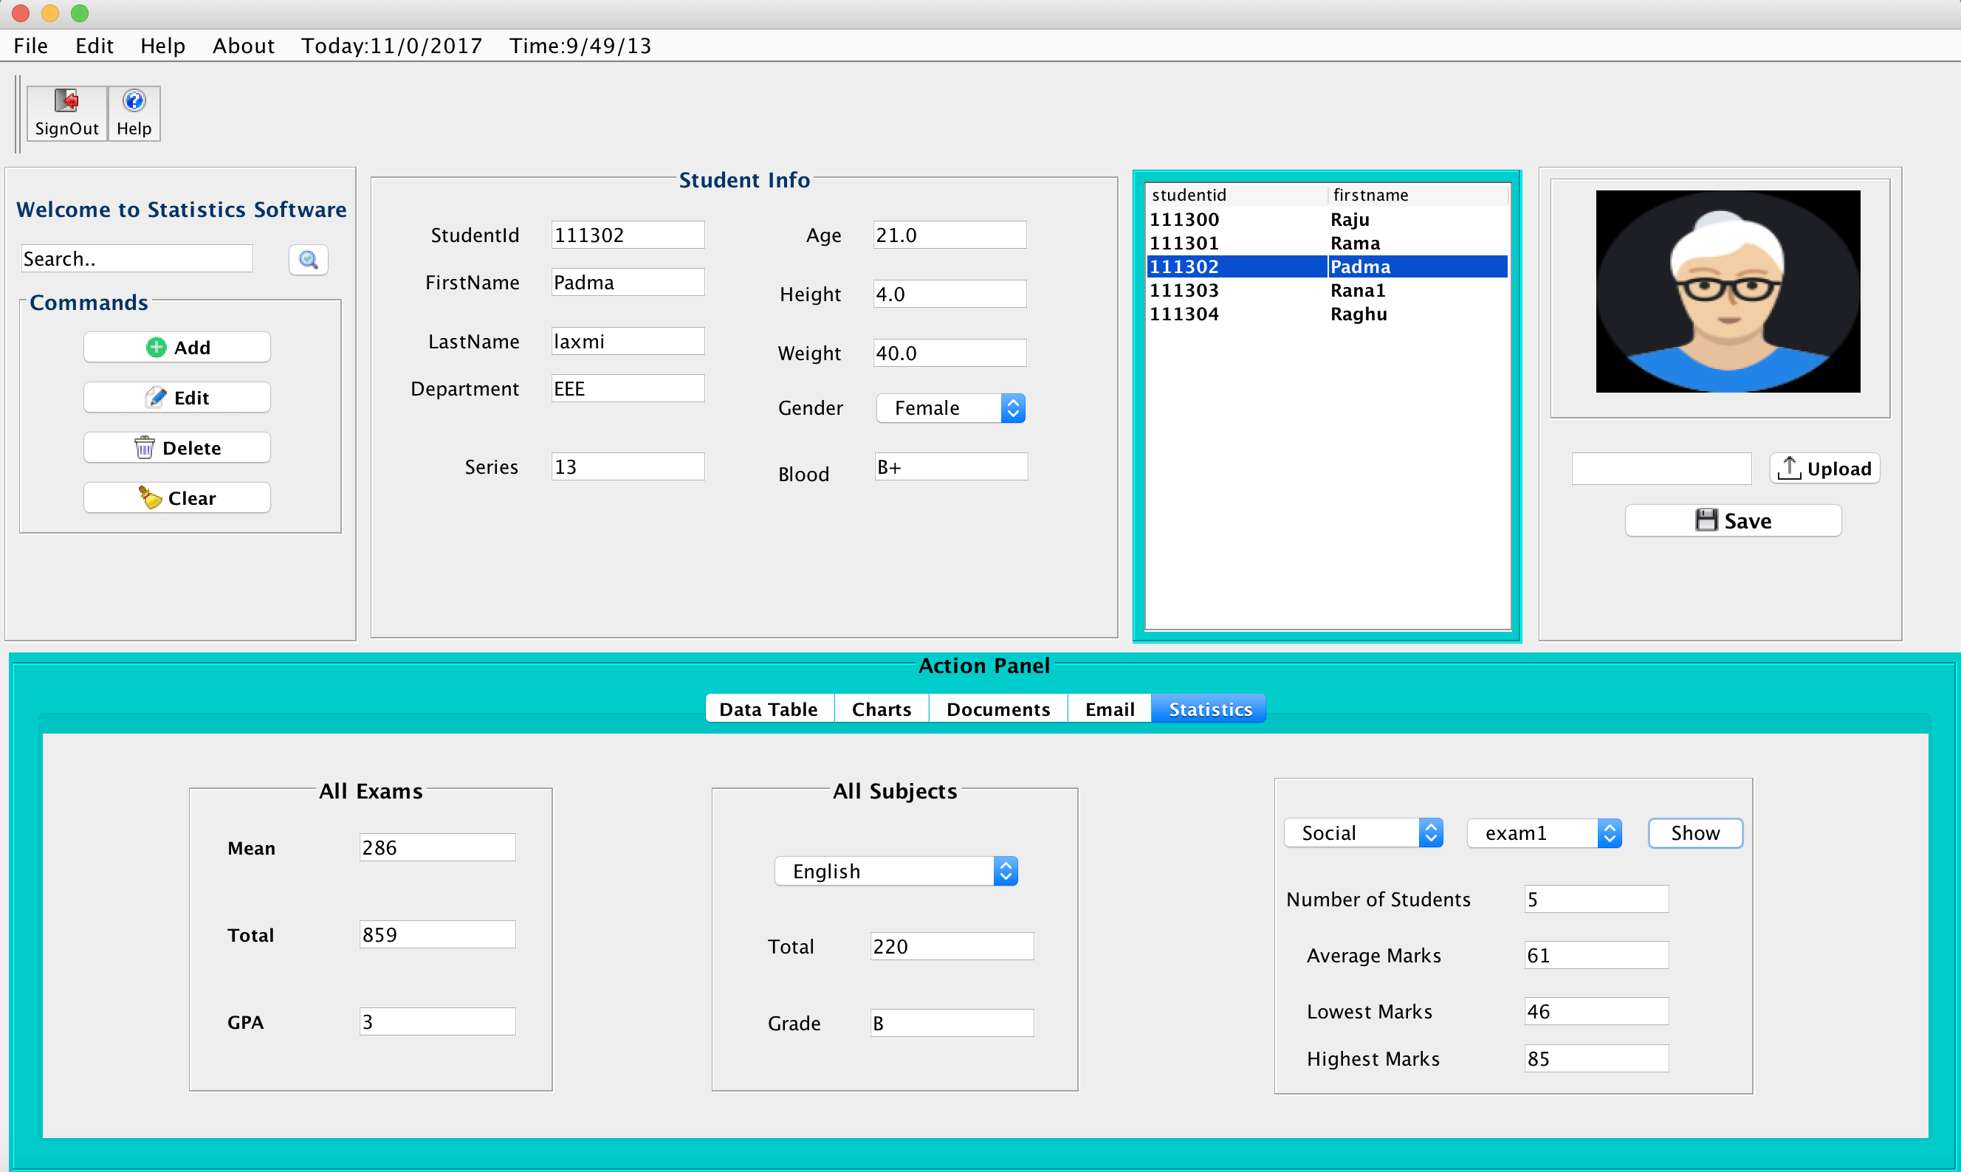

This application needed many external jar files to achieve some functionalities. They are listed below.

1. Itextpdf.jar : To generate pdf report
2. Sqlite-jdbc.jar: To establish connection with sqlite database
3. Jfreechart.jar: To generate charts
4. Mail.jar, smtp.jar: To send emails from the application

Icons in this application has been downloaded from iconfinder.com website.

Below is the screenshot of tables and data created in sqlite database

